Delhi Urban Shelter Improvement Board



VISION DOCUMENT (15 YEAR PERIOD UP TO 2030)

- Delhi Slums Open Defecation Free by March 2018
There are 675 slum & JJ bastis in Delhi having more than 3 lakh jhuggis. The population living in jhuggis is about 15 lakhs. DUSIB has prepared Open Defecation Free plan of action to make these slum & JJ bastis open defecation free.
During April 16 a survey was conducted by DUSIB and 253 OD spots at 216 locations were identified. Based on this DUSIB has conducted gap analysis to provide toilet facilities in these bastis so that these can be made OD free and according to analysis as per SBM guidelines the total requirement of 36600 WC seats are found. There was old norm of 1 seat for 50 persons for providing WC seats in slum bastis, but this norm has been modified in Swachh Bharat Mission policy to 1 seat per 30 persons.
As on 31.03.16 the existing WC seats which are available for these bastis is 17405 which includes 3987 WC seats available in toilet complexes of MCD. However, as per requirement and feasibility DUSIB has planned to construct more than 15000 WC seats.
During this year upto 02.10.16 more than 1700 WC seats are added/renovated and about 5000 WC seats will be added/renovated up to 31.12.16. DUSIB has also planned more than 4000 seats to be added/renovated from 01.01.17 to 31.03.17. During last year i.e 2015-16 about 4000 WC seats were added/renovated, whereas during 2016-17 DUSIB has planned to add/renovate more than 11500 WC seats ( 2000 seats will be renovated and about 9500 new WC seats will added).
In this way upto 31.03.17 the total available WC seats in these bastis will be more than 26500. The balance seats i.e. about 5500 seats will be added by 30.06.17. DUSIB is making all efforts to provide sufficient number of WC seats in all JJ bastis so that slum & JJ bastis of Delhi can be declared technically OD free by 30.06.17.
During year 2015-16 the expenditure on toilet was Rs 45 Crore. For current year the budget allotment has been made for Rs 100 Crore by Delhi Government and Rs 51 Crore has been provided by Central Government and Delhi Government under SBM. DUSIB has spent about Rs 16 Crore till date and the works of Rs 135 Crore are in progress/planning.
DUSIB had conducted competition for innovative design for toilet complex in JJB Bastis and based on this competition the external facia of the proposed complexes has been improvised to give better look. The specifications adopted for toilets have also been improved by providing ceramic tiles up to lintel height inside toilet, kota stone flooring inside and outside to improve cleaning facility which will improve hygiene.
DUSIB has provided tap water to all WC seats in toilet complexes to improve hygienic condition for the users in the complexes.
All signage has been standardised, improved and made more informative. Strict monitoring of the toilet complexes by deploying exclusive teams for regular inspections and Member (Expert) has been entrusted the work of monitoring the O&M of these complexes so that the good quality service can be given to the slum dwellers.
The prefabricated toilet cubicles have also been improved by providing ceramic WC seat and aluminium chequered plate flooring instead of FRP material, which will make more hygienic and durable. The cost of these cubicles are about Rs 22500/- whereas as per SBM guidelines the cost is Rs 32000/- per cubicle.
DUSIB has also planned portable mobile toilets for the locations which are not having water and sewage facilities. These toilets will use chemical technology to recycle the water for flushing and also the sludge will be collected and discharge in nearby sewerage system after 70 to 80 uses. This will be helpful to provide toilet facilities at the location where no water & sewer facilities are available.
DUSIB has made comprehensive plan to make all slum & JJ bastis OD Free by 30.06.17 but to achieve this target cooperation from land owning agencies is also required which is lacking. DUSIB has requested all the land owning departments to issue NOC to construct toilets in these JJ bastis. Except DDA, no other department which includes Railway, South MCD, Revenue department of Delhi Govt., and Irrigation departments of UP & Haryana have given NOC, due to which it is feared that the target set by DUSIB may not be achieved.
It is also noticed that the jhuggi dwellers are not using toilet facilities at some places due to availability of vacant space nearby and also habit to defecate in open. This require constant persuasion and counselling of the dwellers by telling the benefit of using toilets and health problems due to open defecation. NGOs have also been roped in by DUSIB for this purpose.
- Total slum & JJ Bastis in Delhi 675
- Total Jhuggis in these bastis 3 Lakh
- Total population in these bastis 15 Lakh
- Number of WC seats required as per old norms 30000
of 1 WC seat for 50 persons
- Number of WC seats required as per new norms 50000
of 1 WC seat for 30 persons
- Number of OD spots identified during survey done 253 at 216 locations
during April 2016
- WC seats added/renovated during last year up to 31.03.16 4000 No.
- Toilet complexes serving these bastis as on 31.03.16 638 No.
- Total number of WC seats in these complexes 17405
- WC seats planned to be added by DUSIB as per 15000
feasibility & requirement
- WC seats added/renovated during this year up to 02.10.16 1741 No.
- WC seats proposed to be added/renovated up to 31.12.16 4900 No.
- WC seats proposed to be added/renovated up to 31.03.17 more than 4000 No.
- Total number of toilet complexes to be made available 745
for these bastis up to 31.12.16
- Total number of WC seats to be made available 22160
for these bastis up to 31.12.16
- Total number of WC seats to be made available more than 26500
For these bastis up to 31.03.17
- WC seats proposed to be added up to 30.06.17 5500
- Total WC seats to be made available for JJ Bastis 32000
To declare slum & JJ bastis OD free

- Transformation of JJ Bastis as Adarsh Bastis by March 2020
The Government of the National Capital Territory of Delhi (GNCTD) is committed to provide basic facilities to those living in slums. DUSIB which was created in 2010 to facilitate the programme, has mapped the 675 slums that came up across the city before 2006.
Presently, the residents of these JJ Bastis, which are located in urban areas, face a host of problems because of the lack of access to proper sanitation, water supply and hygiene. The most affected are the women, given their household responsibilities, the social inhibitions associated with mobility in public spaces and the fact that water collection, storage and use tend to be their responsibility. They also face a number of problems, especially in the urban context, because they have to resort to open defection.
Under these circumstances, safety, cleanliness and easy access to community toilet complexes (CTCs) have become a necessity and these need to be collectively addressed by the community. However, the issues of urban health and sanitation are complex because many of these settlements are either bastis or unauthorised. It is, therefore, imperative to strengthen community awareness so they can express their grievances and concerns.
In the urban context, it is difficult to collectivize and achieve the cohesiveness necessary to built consensus on possible solutions to a wide range of sanitation priorities and needs. Slum dwellers are not homogeneous by nature, and there are diverse vested interests, particularly landlords and anti-social elements that are making the most of the insecurities of the poor, who are merely looking for a roof over their heads. All these diverse groups have to be engaged with and brought into the planning process and this is best done by strengthening peoples’ participation and building their stakes in the process of change, particularly in the area of sanitation.
Slums identified for Up-gradation and Improvement
To begin with, DUSIB has identified the 52 slums that will be re-developed during the first phase as the Adarash Bastis by March 2018 . The process of community engagement has already begun and in many slums, the residents are deliberating on their needs and demands, and reaching a consensus on where the services and facilities will be located. By March 2020 all the JJ Bastis shall be transformed into Adarsh Bastis.

Memorandum of Understanding (MoU)
Both DUSIB and the NGOs shall enter into a formal collaboration, through a Memorandum of Understanding (MoU) between the Government (DUSIB) and NGOs, to ensure the sharing of responsibilities and ownership of the process.
To begin with, the MoU between DUISB and the NGOs that are spearheading the process of community engagement in the 52 selected slums is being worked out. Once it is agreed upon and advanced, it can be used a model for greater community participation and convergence of all stakeholders.
Key Commitments
The Delhi government has created a roadmap for transforming the bastis into Adarsh Bastis. A deadline of 31st March, 2017 has also been set for the project and the government has identified 52 of the 675 slums in the Capital that will be developed with the impetus on sanitation. The project is being implemented by DUSIB in collaboration with various NGOs and self-help groups (SHGs).
DUSIB is committed to upgrade all the JJBastis by 31st March, 2020. In collaboration with the NGOs, DUSIB will strive to ensure that :
- Toilets are regularly repaired and maintained in good condition.
- Adequate water is supplied by the Delhi Jal Board.
- Street lighting is repaired and maintained by DISCOMs.
- Toilets are connected to existing sewerage line.
- Solid waste management is strengthened with the respective MCDs.
- Existing Bal Vikas Kendras are repaired and maintained.
- Shishu Vatikas are repaired and kept in good condition.

- Slum Rehabilitation to existing / under construction 52344 EWS houses and construction of 70,000 new EWS houses to rehabilitate all slums on DUSIB and GNCTD land.
Under JNNURM scheme of MoHUPA DUSIB has constructed 10684 EWS houses at Dwarka, Sultanpuri and Sawda Ghevra. 7400 EWS houses are under construction at Bhalswa which are likely to be completed by 31.03.2017. Similarly, DSIIDC has constructed 13820 EWS houses under JNNURM and 20440 EWS houses are under construction at various locations in Delhi viz., Pooth Khurd, Baprola, Bawana, Narela, Ghoga and Bhorgarh. Thus a total of 52344 EWS houses constructed under JNNURM are available for Slum Rehabilitation / Relocation as per the Delhi Slum & JJ Rehabilitation / Relocation policy, 2015.
Further, approximately 20000 EWS houses shall be constructed by DUSIB at Sangam Park, Sikri Bhatta, Sultanpuri and Bhalswa Jahangirpuri by 2020. The JJ bastis existing in the Assembly Constituencies viz., Model Town AC-18, Sultanpuri, AC-10 and Rajouri Garden, AC-27 in the phase-1 and JJ Bastis in Assembly Constituencies Badli AC-5, Adarsh Nagar AC-4, Burari AC-2 in the phase-2 shall be rehabilitated.
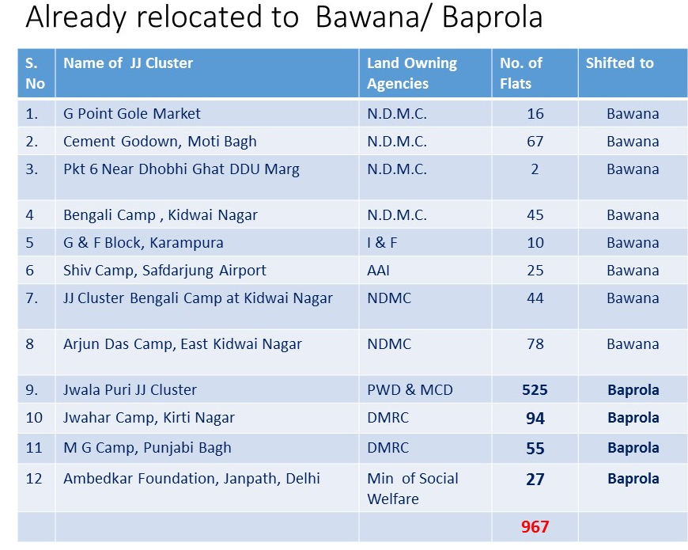
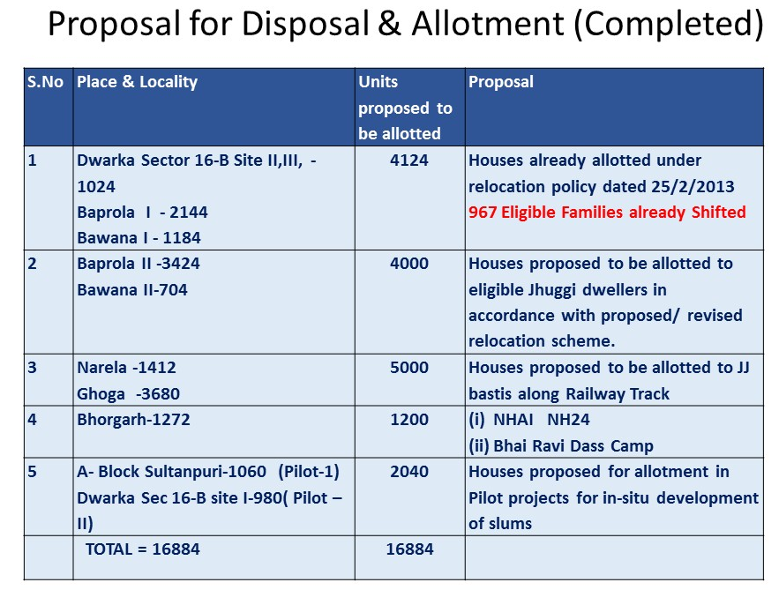
Proposal for Disposal and allotment of Completed EWS Houses
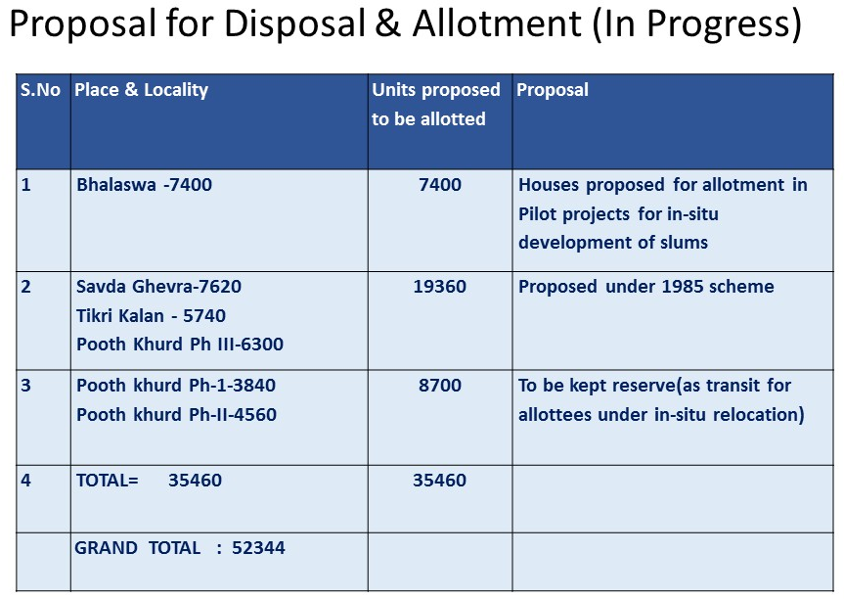
Proposal for Disposal and allotment of EWS Houses(In Progress)
Proposal for construction of about 20,000 EWS houses by 2020
S.No | Location |  | No. of DUs
1 | Sangam Park |  | 1518
2 | Sultan Puri |  | 3000
3 | Rajouri Garden |  | 2166
4 | Mangol Puri |  | 935
5 | Bhalswa |  | 12000
 | Total |  | 19619

Proposal for construction of about 30,000 EWS houses by 2024

1 | Jangpura, Kondli, Trilokpuri | 6500
2 | Debli,Ambedkar nagar, kalkaji, Shahdra, Seelampuri, Patel nagar, Madipur | 23000
3 | Hari nagar ashram | 900
 |  | 30,400

REHABILITATION PLAN OF JJBs on DUSIB LAND
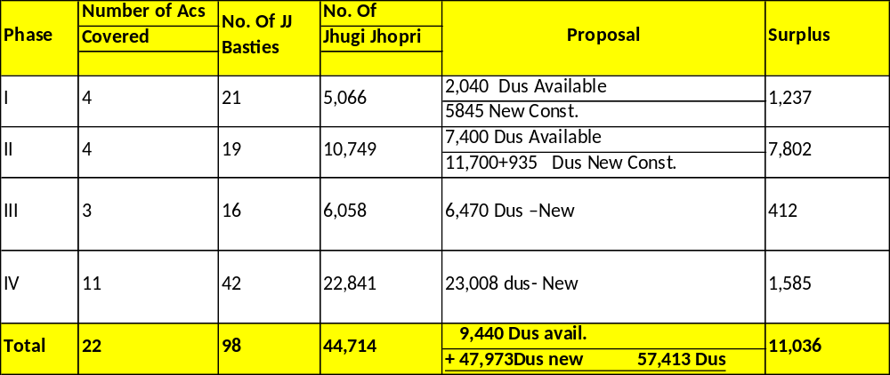
All the JJ Bastis from the land of DUSIB shall be rehabilitated on DUSIB Land and JJ Bastis on the land of other Delhi Govt.departments shall be adjusted on the surplus flats available as per the provisions of Delhi Slum and JJ Rehabilitation/Relocation policy – 2015.Rehabilitation/relocation of JJ Bastis on land of Central Govt. departments shall be taken up only on their request.

4.Construction of 14new shelters for homeless under NULM by 2030 and refurbished all shelters by 2020.
14 land pockets of 1000 sqm. or more are available for construction of permanent Shelter for urban homeless. Sanction has been accorded for construction of 4 nos. permanent shelters to the tune of Rs. 35 crores and for refurbishment of 13 nos. of existing shelters to the tune of Rs. 6.25 crores. Further, sanction has also been accorded for operation and management of 197 shelters @ Rs. 50,000/- per shelter per month. DUSIB shall construct 4 new Night Shelters for homeless under NULM by 2020 and refurbish 13 existing shelters by March, 2018 and further construct 10 new Night Shelters under NULM by 2020. All the shelters shall be refurbished by 2020 and further 9 new shelters shall be constructed for homeless under NULM.
DUSIB plans to construct sufficient number of shelters in the National capital for the homeless people.
5.Removal of Dark Spots from JJ Bastis
Dark spots are the stretches of land about 30m either way , noticed during survey by field staff in Night hours where street light is not available and area is under darkness. DUSIB plans to remove all these dark spots under the plan schemes.
6.EIUS
There are 675 JJ Bastis with about 306602 jhuggies and about 12.32 lakh population. These slums are spread all over Delhi with highest concentration in areas where commercial activities take place. To improve the living condition of these slums under the plan scheme of Environment Improvement in Urban Slums, DUSIB is providing the facility of paved pathways to make room for easy flow of pedestrians, bicycles and hand-carts etc. on paved roads to avoid mud and slush and open surface drain for smooth flow of waste water.
DUSIB is providing CC pavement with open drain in all JJ Bastis and all these bastis shall have proper pavement and open drains by 2020. This is a continuous process to provide repair to the damaged pavement / drain by replacing after every 5 years,until these JJ Bastis are rehabilitated/relocated.
7. Shishu Vatika
Delhi has become hub of concrete buildings, metallic roads, fly-overs with hardly very little space for parks/woods. Clean Delhi, Green Delhi is the slogan that is promoted by the Delhi government who would not like rows of green trees on the road side, well maintained green lawns and parks, beautiful green natural surroundings gave the capital the title of Green Delhi.In the JJ Bastis the condition is worst due to over densification. In spite of that, DUSIB has developed a large number of Shishu Vatikas (about 400) and parks in these Bastis /resettlement colonies to contribute towards green Delhi.
DUSIB plans to develop these Shishu Vatikas through its Horticulture Division until and unless the JJ Bastis are redeveloped/ re-located under Delhi Slum and JJ Rehabilitation / relocation policy 2015.
8. COMMUNITY HALLS/ BASTI VIKAS KENDRAS (BVKs)
DUSIB is providing the facility of multipurpose community halls in relocation pockets and in notified slum area for organising social and religious functions. The ground floor of most of these community halls is used as Barat Ghars/ social functions for local residents on rental basis whereas first and second floor is allotted to various NGOs/ VOs/ Charitable Trusts/ Govt. Agencies for rendering community development programmes like educational, vocational, health care, Night Shelter, Anganwadis, Libraries/reading rooms, Dispensaries, Adult literacy centres etc. So far 200 Community halls have been constructed at various locations under the jurisdiction of DUSIB.
Similarly, for JJ dwellers DUSIB is providing the built up space in JJ Bastis in the shape of BVKs (300 Nos) for provision of integrated package of services under social consumption sector. These are also allotted to NGOs / UDs / Charitable organisations for extending facilities like health care, skill up-gradation and educational/ vocational programmes to the JJ dwellers. These BVKs are allotted on nominal licence fees of Rs. 2/- per sq. ft. per month and organisation is required to deposit Rs. 10/- per sq. ft with minimum of Rs. 10,000/- as security. These Community Halls/ Basti Vikas Kendras shall be maintained and new ones shall be constructed as per the requirement.
9.STRUCTURAL IMPROVEMENT OF KATRAS
In the notified slum area for structural safety of 2893 slum katras owned by DUSIB and provision of common facilities such as replacement of sewerage/ water supply system, CC paving in courtyards etc in private katras, DUSIB is implementing plan scheme of Structural improvement of katras. During the next Annual Plans repair work in slum Katras and common services in Private Katras shall be provided.
DUSIB plans to expend Rs.3.00 to Rs.5.00 Crores per annum in the slum Katras for providing the above mentioned common facilities.

